Kiewit Steel Calculator
CIVE 202 Project 5
Tom Steele
Group 1-30

Introduction
This project was established with the goal to fulfill a client’s request by creating a calculator capable of determining the allowed forces in a W-shaped tension member. The request included a demonstration of its efficacy with different beam sizes and strengths and graphical outputs to represent them. The client also desired detailed instructions as to the usage of the calculator, which have been included in this report, and a breakdown of the coding choices made, which is attached. The calculator was constructed with the ability to take user inputs on steel grade and beam size and return values such as the design tensile and rupture yield, allowable tensile and rupture stress, and overall tensile and rupture strength. It was also created with the ability to determine all of these values from an uploaded CSV file and graphically represent the variance caused by changing different inputs (example provided in Fig 1).

Methodology
Before the construction of the calculator could begin, research was required. Equations for the required outputs of the particular beam shape required were found in the AISC Steel Construction Manual. Once these were known, the calculator was built in Python. Functions were defined to request user inputs for the necessary variables, and others were constructed to run through each necessary equation. These sets of functions were combined so that running the calculator will first ask the user for variables and then return the desired tensile strength values. The same set of functions was used in a different manner to read the beam data uploaded in a CSV file and output the correct results for each value uploaded as a variable. These results were then plotted on line graphs to show the difference that changing inputs can create in the final governing design and allowable tensile strengths of a beam.

Instructions For Use
To use the calculator, first run the simulation. It will ask for four values to input, without which it cannot calculate all of the desired outputs. Enter the gross area and net area of your tension member, as well as the designated steel grade (represented by a specified minimum ultimate strength and minimum yield strength). From there, the calculator will output nominal yield and rupture strength, design and allowable tensile yield, design and allowable tensile rupture, and design and allowable tensile strength, the governing values. If you wish to test many differing values of steel grade or area, upload your values as a CSV in the specified section.

Executive Summary
To create a future calculator, similar functions can be crafted. Most of the functions defined in this set of code are simple equations taking input and performing easy mathematical operations, as this is the most efficient way to cause a computer to do math for you. Other types of calculators requiring similar functions could take from this one, repeating the same steps to acquire user inputs and changing only the equations used in their functions. The same goes for the graphical representation of data, very similar code can be used to show the relationship between inputs and outputs of any equation. Once new functions are established, the same user interface can be utilized with almost no changes, merely a slight difference in request communication. The calculator is simple and repeatable, very easily recreated, adapted, and expanded upon to solve more types of problems.

Results and Discussion
This calculator is able to determine all of the values for tensile strength in a W-shaped member and provide the governing values of each type of tensile strength. With the uniformity this calculator provides, different employees can be certain of achieving the same, correct results when working on a project involving this kind of loading. This level of standardization increases efficiency in the workplace and accuracy of important calculations. Future calculators could be created to run other types of calculations on similar beams in the future, a task made easier by the fact that many of the same tests need to be run and many of the same equations will be used.

Possible Bias
The decision was made to ask the user for specific inputs to do with the particular member they need information on at present. This was instead of allowing the upload of multiple data sets at once, which would have been a more efficient model, but less effective at providing individual data. With the calculator as it is at present, simple calculations can be made for the project at hand at a moment’s notice, instead of forcing employees to spend time and energy collating data in a larger, more unwieldy form. If they wish to do this to see a graphical representation of the results of their data, the code can support such an action, but the main calculator and its functions are not designed to encourage this.

Conclusion
The client’s request for a proof of concept program has been fulfilled. The calculator for a W-shaped tension member is fully capable of performing all necessary calculations for the tension it will be under, and is equally capable of showing a graphical representation of these determinations. Instructions for the calculator’s use have been included in this report, and a breakdown of the purpose of each section of code has been attached. A project schedule and engineering timesheet showing billable hours are also included, as is the rough data used to determine variance in a steel beam’s governing strengths.

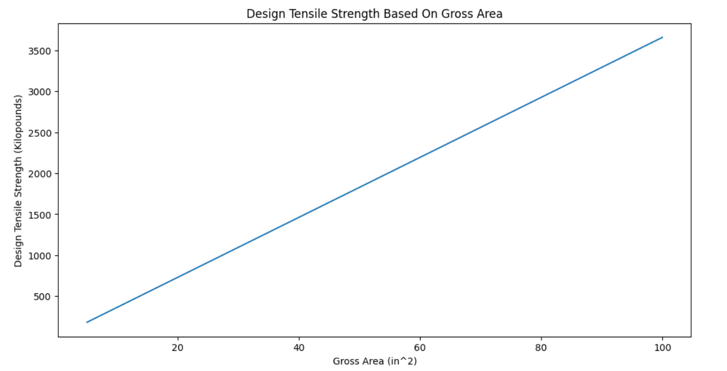
Fig 1.

